Step by step process to transfer files from inside docker container to the local / laptop file system

**Step 1:** Test transfer of a test file from the RedTeam VM to the local/laptop file system

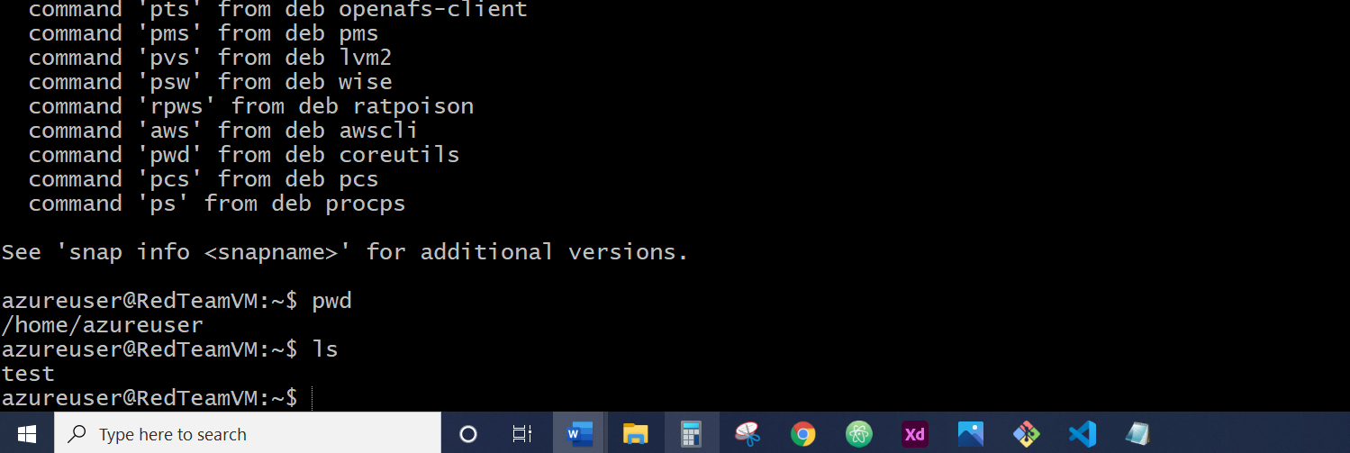

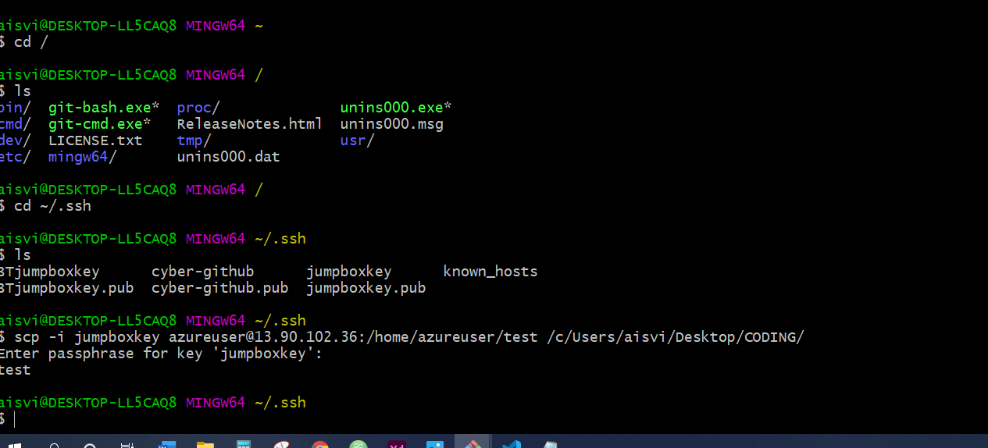

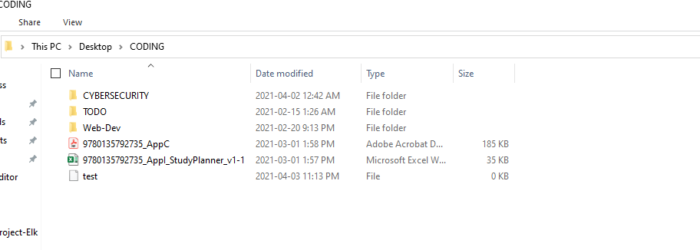

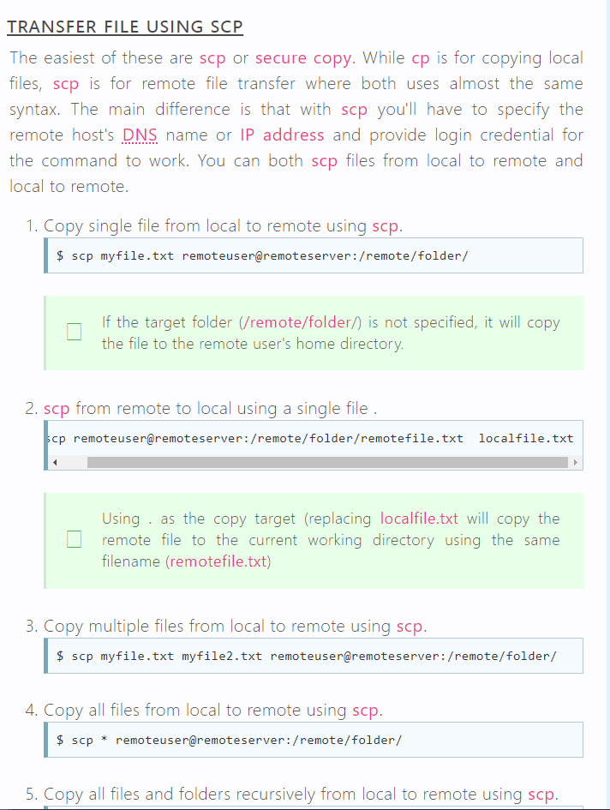

Step 2: Transfer the files from inside the docker container (you need to ensure that the docker container is running and note that you would need to open at least two gitbash terminals to execute the commands)

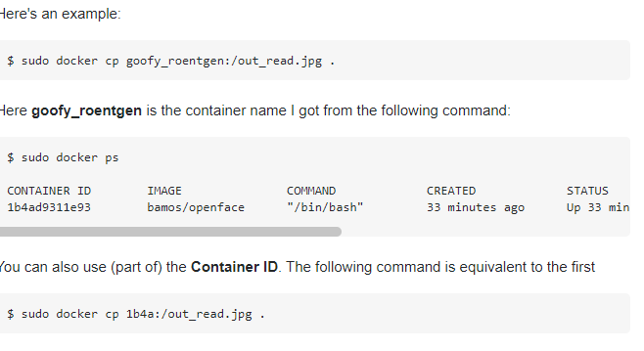

<https://docs.docker.com/engine/reference/commandline/cp/>

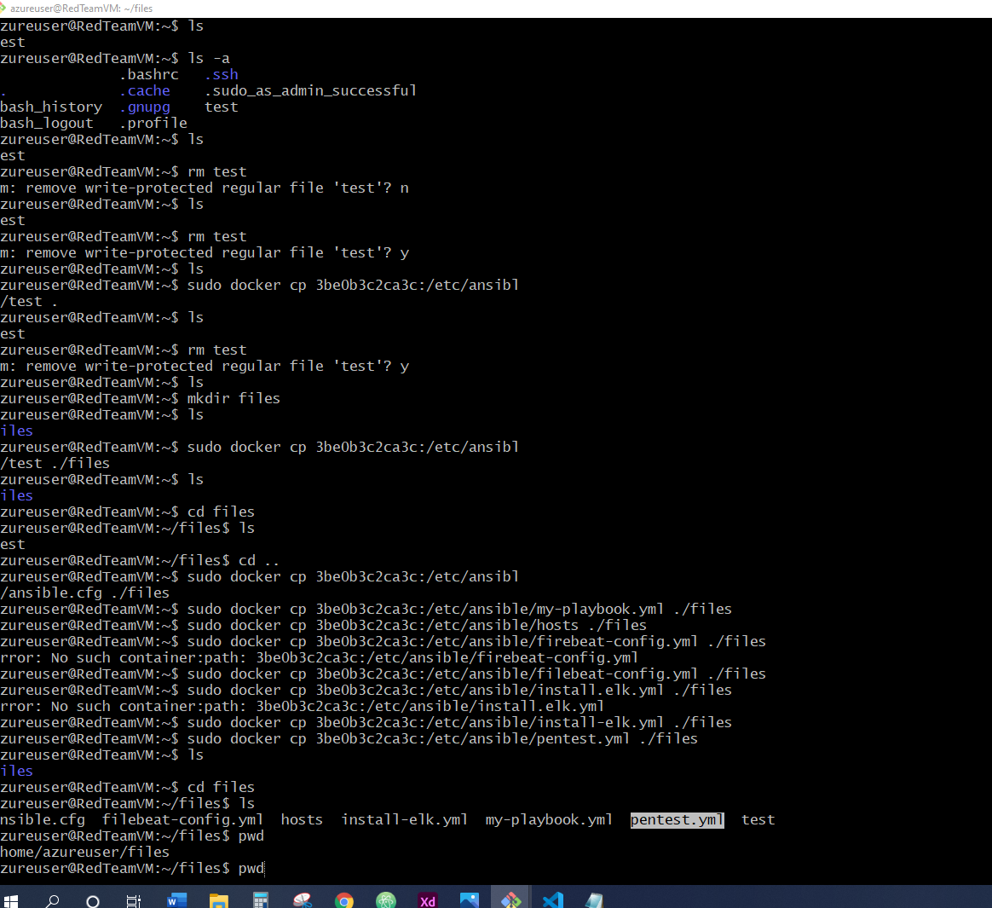

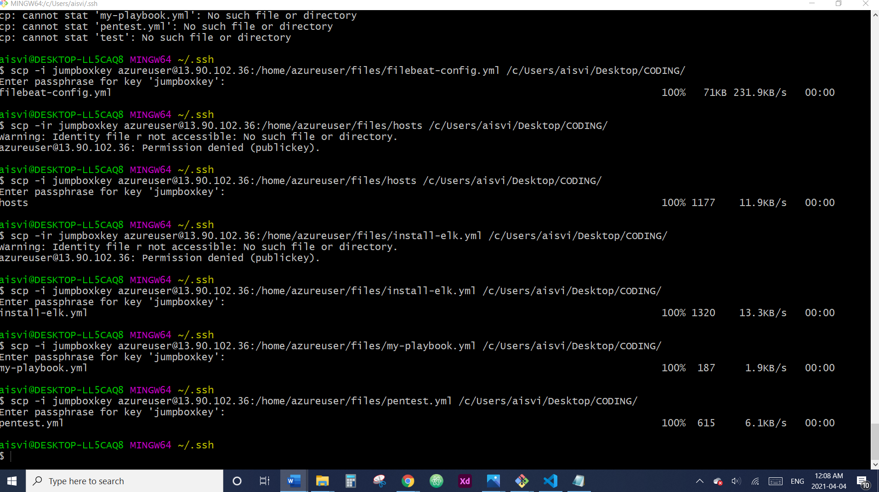

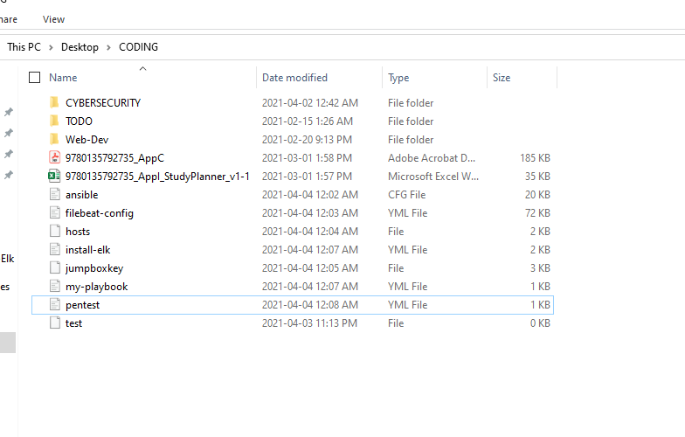

104 sudo docker start tender_goldstine

105 sudo docker attach tender_goldstine

106 ls

107 clear

108 sudo docker attach tender_goldstine

109 sudo docker start tender_goldstine

110 sudo docker attach tender_goldstine

111 ls

112 ls -a

113 clear

114 ls

115 ls -a

116 sudo docker start tender_goldstine

117 sudo docker attach tender_goldstine

118 ls

119 touch test

120 ls

121 scp test aisvi@67.71.15.12:/c/Users/aisvi/Desktop/CODING/

122 clear

123 exit

124 sudo docker ps -a

125 ls

126 docker cp root@3be0b3c2ca3c:/etc/ansible/test .

127 docker cp 3be0b3c2ca3c:/etc/ansible/test .

128 clear

129 sudo docker cp root@3be0b3c2ca3c:/etc/ansible/test .

130 sudo docker cp 3be0b3c2ca3c:/etc/ansible/test .

131 ls

132 ls -a

133 ls

134 rm test

135 ls

136 rm test

137 ls

138 sudo docker cp 3be0b3c2ca3c:/etc/ansible/test .

139 ls

140 rm test

141 ls

142 mkdir files

143 ls

144 sudo docker cp 3be0b3c2ca3c:/etc/ansible/test ./files

145 ls

146 cd files

147 ls

148 cd ..

149 sudo docker cp 3be0b3c2ca3c:/etc/ansible/ansible.cfg ./files

150 sudo docker cp 3be0b3c2ca3c:/etc/ansible/my-playbook.yml ./files

151 sudo docker cp 3be0b3c2ca3c:/etc/ansible/hosts ./files

152 sudo docker cp 3be0b3c2ca3c:/etc/ansible/firebeat-config.yml ./files

153 sudo docker cp 3be0b3c2ca3c:/etc/ansible/filebeat-config.yml ./files

154 sudo docker cp 3be0b3c2ca3c:/etc/ansible/install.elk.yml ./files

155 sudo docker cp 3be0b3c2ca3c:/etc/ansible/install-elk.yml ./files

156 sudo docker cp 3be0b3c2ca3c:/etc/ansible/pentest.yml ./files

157 ls

158 cd files

159 ls

160 pwd

161 history

390 ssh -i jumpboxkey azureuser@13.90.102.36

391 ls

392 cd usr/

393 ls

394 cd ..

395 cd ..

396 ls

397 ls -a

398 cd ~

399 ls

400 whoami

401 exit

402 whoami

403 pwd

404 cd ~

405 pwd

406 cd Desktop/

407 cd CODING/

408 pwd

409 scp azureuser@13.90.102.36:/test /c/Users/aisvi/Desktop/CODING

410 scp azureuser@13.90.102.36:/test /c/Users/aisvi/Desktop/CODING

411 pwd

412 scp azureuser@13.90.102.36:/home/azureuser/test .

413 cd ..

414 cd ..

415 cd /

416 ls

417 cd ~/.ssh

418 ls

419 scp -i jumpboxkey azureuser@13.90.102.36:/home/azureuser/test /c/Users/aisvi/Desktop/CODING/

420 exit

421 history

422 ls

423 cd ~/.ssh

424 scp -i jumpboxkey azureuser@13.90.102.36:/home/azureuser/files /c/Users/aisvi/Desktop/CODING/

425 scp -ir jumpboxkey azureuser@13.90.102.36:/home/azureuser/files /c/Users/aisvi/Desktop/CODING/

426 scp -i jumpboxkey azureuser@13.90.102.36:/home/azureuser/files/ansible.cfg filebeat-config.yml hosts install-elk.yml my-playbook.yml pentest.yml test /c/Users/aisvi/Desktop/CODING/

427*

428 scp -ir jumpboxkey azureuser@13.90.102.36:/home/azureuser/files/hosts /c/Users/aisvi/Desktop/CODING/

429*

430 scp -ir jumpboxkey azureuser@13.90.102.36:/home/azureuser/files/install-elk.yml /c/Users/aisvi/Desktop/CODING/

431 scp -i jumpboxkey azureuser@13.90.102.36:/home/azureuser/files/install-elk.yml /c/Users/aisvi/Desktop/CODING/

432 scp -i jumpboxkey azureuser@13.90.102.36:/home/azureuser/files/my-playbook.yml /c/Users/aisvi/Desktop/CODING/

433 scp -i jumpboxkey azureuser@13.90.102.36:/home/azureuser/files/pentest.yml /c/Users/aisvi/Desktop/CODING/

434 history